Section 1.2 (Basics of Functions and Their Graphs)

Within ordered pairs (any set of ordered pairs is also called a relation), the first components are called the domain (usually the x-coordinate) and the second components are called the range (the y-coordinate) of the relation.
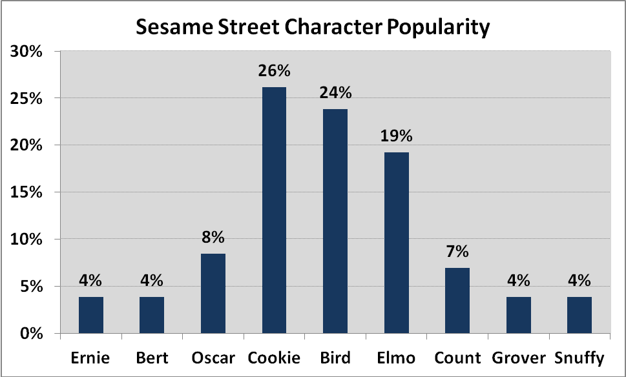
Here, the correspondence between the character and their popularity is {(Ernie,4), (Bert,4), (Oscar,8), (Cookie,26), (Bird,24), (Elmo,19), (Count,7), (Grover,4), (Snuffy,4)}

The domain (1st values) is

The range (2nd values) is

A function is a relation in which each element in the domain corresponds to exactly 1 element of the range

Example: Determine if the following are functions

Domain Range
{(1,2), (3,4), (3,5), (4,6)} {(1,5), (2,5), (3,5)}
4%
7%
8%
19%
24%
26%
Ernie
Bert
Oscar
Cookie
Bird
Elmo
Count
Grover
Snuffy

Domain:

Range:

Functions are usually given in terms of equations rather than as sets of ordered pairs. For y to be a function of x, each value for x should correspond to only 1 value for y.

Example: Determine whether each equation defines y as a function of x (x is the independent variable and can be assigned any value in the domain; y is the dependent variable because its value depends on x)

y = 3 – x² x² + y² = 16

Functions are often listed as “f of x”, “g of x”, etc. and written as f(x), g(x), h(x), etc. and represent the value of the given function evaluated at the number x.

Example: Consider the function y = “f of x” = f(x) = 2x² – x. Evaluate f(2), f(x+1) and f(-x).

f(2) = 2(2)² – 2 = 6, f(x+1) = f(-x) =

The graph of a function is a graph of the ordered pairs that solve the function.

Example: Graph f(x) = 2x + 1, g(x) = 2x and describe how they are related

Example: Graph g(x) = |x| and h(x) = |x| - 3 using x = -3, -1, 0, and 2 then describe how they are related

The vertical line test can be used to determine if a graph denotes y as a function of x. If any vertical line intersects the graph in more than 1 point, the graph does not define y as a function of x.

Example: Determine if the following graphs have y as a function of x

Example: Find h(-2) in the above example and find the value of x for which h(x) = - 3

Example: Online HW Examples (domain, range, etc.)

