**Section 1.3** (More on Functions and Their Graphs)

Consider the trends of college football bowl attendance below

Did average attendance at BCS bowls increase or decrease between the 2013 and 2014 bowl seasons?

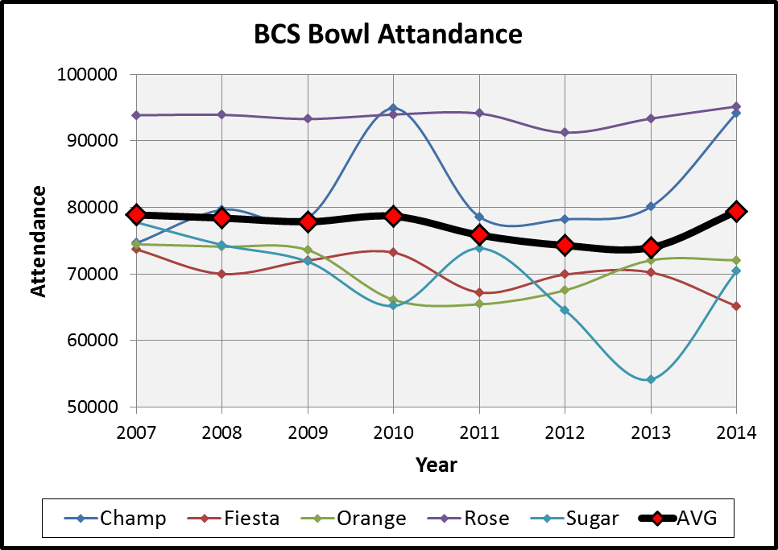

What happened to attendance at the Sugar Bowl between the 2011 and 2013 bowl seasons?

Over what periods did attendance at the championship increase? Decrease?

Bonus: why do you think there are their spikes in BCS championship game attendance in the 2010 and 2014 seasons?

Example: Sketch examples of plots that are increasing, decreasing, and constant in the space below…

Increasing Decreasing Constant

Example: State the intervals (in x) over which the given function is increasing, decreasing, constant



Increasing:

Constant:

Decreasing:

A function f is ***even*** if f(-x) = f(x) for all x (the right side of the equation doesn’t change if x is replaced by –x) and ***odd*** if f(-x) = -f(x) for all x (the right side changes its sign if

x is replaced by –x)

Example: State whether the following are even, odd, or neither

f(x) = x7 + x5 g(x) = x10 + x5 h(x) = x4 – x8

A function that is defined by 2 or more equations over a specified domain is called a ***piecewise function***

Example: Hooper’s Store on Sesame Street began offering a cell phone plan this week that charges $20 per month for up to 120 minutes. Any additional minutes add $0.20 per minute. Representing this plan by writing the total monthly cost (C) as a function of minutes (t) gives…

C(t) = 20 if t < 120 Describe C(30) and C(160)

20 + 0.2(t - 120) if t > 120

A graph is ***symmetric with the y-axis*** if for every point (x,y) on the graph, (-x,y) is also on the graph (the graph can be flipped over the y-axis without changing). The graphs of ***even*** functions are symmetric with the y-axis.

A graph is ***symmetric with the origin*** if for every point (x,y) on the graph, (-x,-y) is also on the graph (the graph can be flipped diagonally through the axis without changing). The graphs of ***odd*** functions are symmetric with respect to the origin.

(Note that symmetry about the x-axis is possible but not discussed)

Example: Are the following functions even (think x2), odd (think x3) or neither?

|  |  |  |  |  |  |  |  |  |  |  |  |  |  |
| --- | --- | --- | --- | --- | --- | --- | --- | --- | --- | --- | --- | --- | --- |
|  |  |  |  |  |  |  |  |  |  |  |  |  |  |
|  |  |  |  |  |  |  |  |  |  |  |  |  |  |
|  |  |  |  |  |  |  |  |  |  |  |  |  |  |
|  |  |  |  |  |  |  |  |  |  |  |  |  |  |
|  |  |  |  |  |  |  |  |  |  |  |  |  |  |
|  |  |  |  |  |  |  |  |  |  |  |  |  |  |
|  |  |  |  |  |  |  |  |  |  |  |  |  |  |

for h ≠ 0 is used to find avg. rate of change and is called the ***difference quotient***

Example: If f(x) = 3x2 + x – 3, find and simplify f(x + h) and for h ≠ 0

Look at online HW examples

