Section 1.5 (More on Slope)

Two nonvertical lines are ____________________ if they have the same slope and different y-intercepts. Two nonvertical lines are _____________________ (they intersect at a 90º angle) if the product of their slopes is -1 (negative reciprocals). Draw and explain on board (for perp. use a line with slope a/b and rotate 90º).

Example: Are the following pairs of lines parallel, perpendicular or neither?

5y = –2x + 1 x – 4y = 3 –2x + 3y = 1

4x + 10y = 3 3x + 12y = 7 3x + 2y = 12

Example: Find the slope of lines parallel and perpendicular to y = 3x – 7

Example: Find an equation of the line containing the point (–1, 2) and parallel to 3x + y = 5 (point-slope and slope-intercept and general (standard) form).

Example: Find an equation (slope-intercept) that describes the line containing the point (3,4) and perpendicular to the line 2x + 4y = 5.

Forms of Linear Equations
General form (A and B are not both 0) | Ax + By = C
Slope-intercept form (slope is m and y-intercept is (0,b) | y = mx + b
Point-slope form (slope is m and (x₁,y₁) is a point on the line) | (y - y₁) = m(x – x₁)
Horizontal line (slope is 0 and y-intercept is (0,c)) | y = c
Vertical line (slope is undefined and x-intercept is (c,0) | x = c
Parallel and Perpendicular Lines
Nonvertical parallel lines have the same slope. The product of the slopes of two perpendicular lines is -1.
Slope can also be considered as a rate of change (ratio of a change in y to a corresponding change in x)

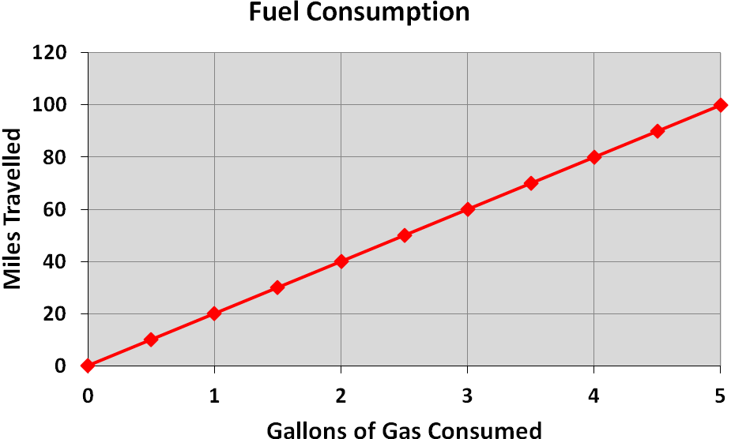Example: The following graph shows data for Oscar the Grouch’s Minican driven on interstate highways. Find the rate of change (miles per gallon)

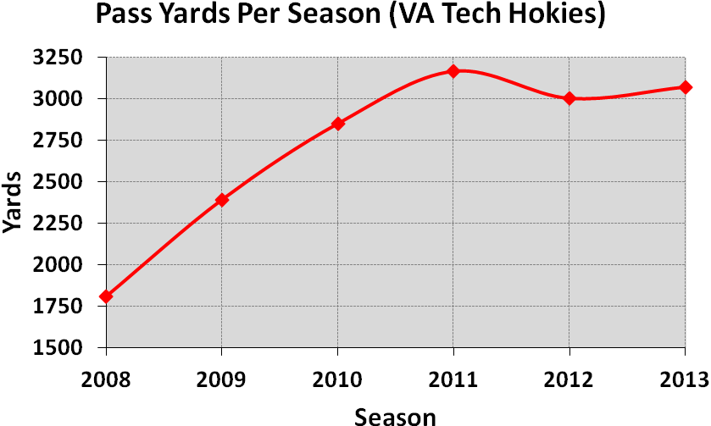Example: Given the graph below, what is the average rate of change in Hokie rushing yards from years 2009 to 2012?

Yds. changed from _____ to
Δy
_____ or _____ yds.

Change occurred from 2002
to 2005 or over a period of
Δx
______ years

Avg. rate of change was
Δy
Δx

thus _____ / _____
or ______ yds. / year

Given 2 distinct points (x₁,f(x₁)) and (x₂,f(x₂)) of a function f, the avg. rate of change between these 2 points is given by -- (This is also the slope / secant line – plot on board)

Example: Find the average rate of change of f(x) = x² and note the slope from

x₁ = 0 to x₂ = 2 x₁ = 2 to x₂ = 4

Common application: Average velocity of an object. Suppose a function expresses an object’s position s(t) in terms of time t. The average velocity of the object from time t₁ to time t₂ is

Example: In a trip to Blacksburg to watch the awesome Hokies win another bball game, I learned that the distance or my position s(t), in miles, that I had travelled was given by s(t) = 16t², where t was the time, in hours, after the I left Huntsville (apparently, I drove faster over time). Find my average velocity (distance / time)…

From t₁ = 1 to t₂ = 2 hours (what was my average driving speed during my second hour on the road) ?

From t₁ = 1 to t₂ = 1.5 hours (what was my average driving speed during this interval on the road) ?
The avg. rate of change of f from x1 = x to x2 = x + h is (from section 1.3). What is h in the examples above?

As the interval get smaller and smaller, we get closer to discovering the instantaneous velocity of my car (discuss another example of average velocity vs. instantaneous velocity of a ball rolled down a ramp)

