**Section 4.1** (Angles and Radian Measure)

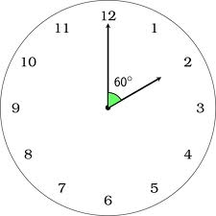

**Vertex**

**Angle**

Consider the hands on a clock (show on board). You could think of each hand on a clock representing a ***ray*** (a line that has an endpoint and extends infinitely in the opposite direction). An ***angle*** is formed between the two hands (rays) that have a common endpoint (***vertex***).

For this class, we will mainly consider angles in standard position where the vertex of an angle is at the origin of the rectangular coordinate system and the initial side of the angle lies along the positive x-axis

Example: Circle the vertex of the following angles (positive x-axis is the initial side, and the other ray represents the terminal side of the angle)

**α , positive angle**

**θ , negative angle**

Angles are represented by the amount of rotation from the initial side to the terminal side, and one unit of measure used is ***degrees*** ( o ). By definition, a ray moving around a complete circle has moved 360o.

Example: Draw and discuss the following angles on the board (acute, obtuse, right angle, 180o, and 270o)

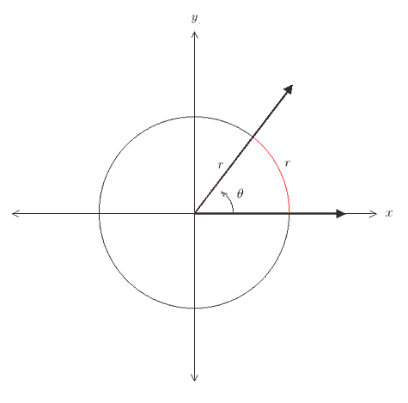

Another way to measure angles is through the use of ***radians***. One radian is the measure of the central angle of a circle that intercepts an arc equal in length to the radius of the circle (1 radian implies the arc length swept out = the radius of the circle)

Consider an arc of length **s** on a circle of radius **r**. The measure of the central angle (**θ**) of that arc is **θ** = $s/r$ (DRAW PICTURE ON BOARD)

Example: A central angle **θ**, in a circle of radius 12 feet intercepts an arc of length 42 feet. What is the radian measure of **θ** ?

Example: The circumference of a circle is given as **C = 2πr**, where **r** is the radius. What is the radian measure of a circle? Half-circle?

So, by the example above and the fact that a circle is 360o, we see that 2π radians = 360o or π radians = 180o.

To convert from degrees to radians, multiply degrees by **π** rad. **/ 180**o (π in numerator)

To convert from radians to degrees, multiply radians by **180**o **/ π** rad. (π in denominator often canceled)

Example: Convert the following angles in degrees to radians (leave π in solution)

**60o 270o –300o 30o**

Example: Convert the following angles in radians to degrees (evaluate for π)

$\frac{π}{4}$ radians $\frac{-4π}{3}$ radians **1** radian $\frac{π}{2}$ radians

We can always convert angles from radians to degrees (which is more familiar to some), but it is helpful to consider angles in standard position via radians as well. Sketch the following angles on the board (2π, π, π/2, 3π/2 radians) before examining the next example…

Example: Draw and label each angle in standard position (**SHOW** figure 4.15 and table 4.1 on pg. 467)

**θ** = $\frac{π}{4}$ **α** = $\frac{3π}{4}$ **α** = $\frac{-π}{4}$ **β** = $\frac{-2π}{3}$ **θ** = $\frac{13π}{4}$

Two angles with the same initial and terminal sides (but possibly different rotations) are called coterminal angles.

Example: Consider / sketch: **90o** and **– 270o**angle and $\frac{9π}{4}$

Example: Find a positive angle less than 360o that is coterminal with: **400o** angle **–135o** angle

Example: Find a positive angle less than 2π that is coterminal with: $\frac{23π}{5}$ angle **– $\frac{π}{15}$** angle

We can use the formula for radian measure discussed above (**θ** = $/r$) to derive a new formula for arc length

Example: Using our derived formula for arc length ( ), consider a circle with a radius of 6 inches. Find the

length of the arc intercepted by an angle of 45o. Express arc length in terms of pi, then round answer to 2 decimals.

**s2**

Consider a satellite flying in a circular orbit around the earth and its “shadow”

**s1**

**θ**

on the surface as it rotates. As the satellite revolves, the distance travelled

by the satellite (arc length) is greater than the distance (arc length) travelled

by its “shadow” over the same angle. Thus, the satellite has a greater **linear**

**speed** (linear distance travelled versus time) than the “shadow” despite the

fact that the satellite goes through the same angle. The **angular speed**

(amount of angle travelled versus time) of the satellite and the “shadow” are

the same. See a similar example using a carousel on pg. 471 in the book.

If a point is in motion on a circle of radius **r** through an angle of **θ** radians over time t,

its **linear speed** is **v = s / t** where **s** is the arc length given by **rθ**

its **angular speed** is **ω =** **θ / t**

Example: The Disneyland Ferris wheel has a radius of 75 feet. The wheel rotates at 2 revolutions per minute. Find the linear speed in feet per minute of a seat on this Ferris wheel.

**v = s / t = rθ / t =**