**Section 4.3** (Right Triangle Trigonometry)

Trigonometry (measurement of triangles) is used in navigation, building, and engineering, among other applications as we will see throughout this section. Consider the angle **π/3** on the unit circle as examined in the last section. Now construct a right triangle by dropping a line segment from our point perpendicular to the x-axis.

**θ**

**1**

**x2 + y2 = 1**

**Right Triangle Definitions of Trig. Functions**

**θ**

Using this right triangle with angle **θ** and the

**1**

that y = r sin(t) and x = r cos(t), we see

**y**

that sin(**θ**) = **y** = **y/1** and cos(**θ**) = **x** = **x/1**

**x**

In many applications it is helpful to interpret

**x2 + y2 = 1**

trigonometric functions using these right triangles. Using the triangle below, construct the six trigonometric functions …

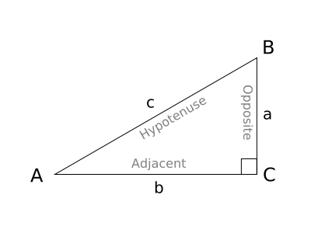

The six trigonometric functions of acute angle θ are defined as

**θ**

|  |  |  |  |  |  |  |  |  |  |
| --- | --- | --- | --- | --- | --- | --- | --- | --- | --- |
| sin θ | = | opposite | = | a | csc θ | = | hypotenouse | = | c |
| hypotenouse | c | opposite | a |
| cos θ | = | adjacent | = | b | sec θ | = | hypotenouse | = | c |
| hypotenouse | c | adjacent | b |
| tan θ | = | opposite | = | a | cot θ | = | adjacent | = | b |
| adjacent | b | opposite | a |

One way to remember is via SOHCAHTOA (**S**ome **O**ld **H**okies **C**ame **A**round **H**ere and **T**ook **O**ut **A**la-bleh-ma)

The trigonometric values of angle θ are the same despite how large the triangle is (see similar triangles on pg. 491)

Example: Find the value of each of the 6 trigonometric functions of θ in the figure

**θ**

**A**

**C**

**B**

**a=3**

**b=4**

**c**

sin θ = csc θ =

cos θ = sec θ =

tan θ = cot θ =

Example: Find the value of each of the 6 trigonometric functions of θ in the figure (simplify answers)

**θ**

**C**

**b**

**c=5**

**A**

**a=1**

**B**

In section 4.2, we used points on the unit circle to evaluate the trigonometric identities of a 45o or π/4 angle. We can similarly determine the trigonometric identities by constructing a right triangle with a 45o angle (see figure 4.34).

Example: If a triangle has angles of 90o and 45o, what must the other angle measure (how many total degrees are in a triangle)?

Example: Given that this is an isosceles triangle (2 equal angles and 2 equal sides), if we let the 2 equal legs have a length of 1, what will be the length of the other side?

Example: Sketch triangle on board and determine trigonometric values of 45o or π/4 angle

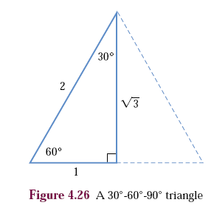Two other angles commonly found throughout trigonometry are 30o and 60o (π/6 and π/3 angle). We can derive information on these angles by starting with an equilateral triangle (3 equal angles and sides) and dividing it into 2 right triangles.

Example: Completely label the triangle on the left

Example: Find sin 30o, cos 60o, tan 30o, and tan 60o

You will need to be able to construct 45-45-90 and 30-60-90 triangles from memory by recalling these (practice on board with time)

Two angles are considered complements if their sum is 90o or π/2. Refer to the right triangle below which has 2 acute angles that are complements (θ and 90-θ).

Example: Find sin θ and cos (90-θ)

**θ**

**A**

**C**

**B**

**a**

**b**

**c**

**90-θ**

Because sin θ = cos (90-θ) and vice versa, sin and cos are called **cofunctions**

**Cofunction Identities**

sin θ = cos (90-θ) --- cos θ = sin (90-θ)

tan θ = cot (90-θ) --- cot θ = tan (90-θ)

sec θ = cos (90-θ) --- csc θ = sin (90-θ)

Example: Find a cofunction with the same value as the given expression: sin (**46o**) cot (**π/12**)

Many applications of right triangle trigonometry involve the angle made with an imaginary horizontal line. An angle formed by a horizontal line and the line of sight to an object above the horizontal line is called the **angle of elevation** (below the horizontal is called the **angle of depression**). – SEE FIGURE 4.37 – pg. 495

Example: Sighting the top of Lane Stadium, a surveyor measured the angle of elevation to be 24o. The transit (measuring platform) is 5 feet above the ground and 300 horizontally from the stadium. Find the stadium’s height.

***VT***



GO HOKIES !!

10

10

**5 ft**

**24o**

**300 ft**

If two sides of a right triangle are known, you can use inverse trigonometric functions to find an acute angle θ

Example: Use you calculator to find θ where sin θ = 0.866

Example: The flagpole in the middle of Sesame Street is 14 meters tall and casts a shadow 10 meters long. Sketch the problem and find the angle of elevation of the sun to the nearest degree.