**Section 4.7** (Inverse Trigonometric Functions)

Inverse function attributes:

* In order for a function to be one-to-one and have an inverse, no horizontal line should intercept the graph of that function at more than one point
* If the point (a,b) is on function f, then the point (b,a) is on function f – 1 and the graph of f – 1 is a reflection of the graph of f about the line y = x

Considering these attributes, sin, cos, and tan will not have inverse functions over the domain of real numbers. However, if we restrict the domains over certain intervals (why), we can further explore inverse trigonometric functions.

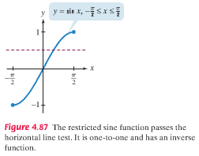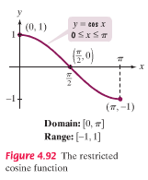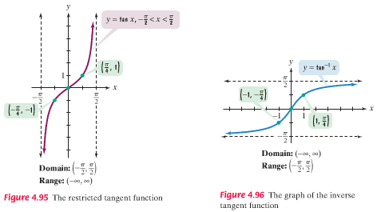

f(x) = sin(x) over **[–π/2, π/2]** f(x) = cos(x) over **[0, π]** f(x) = tan(x) over **(–π/2, π/2)**

We can define inverse functions to each of the trigonometric functions listed above over the given domains

**Important note**: The notation asin x = sin –1 x refers to the inverse function, NOT the conjugate **sin –1 x (1/sin x)**

There are a couple of ways to consider the graphs of inverse functions. One is to reverse the order of coordinates.

Example: Briefly consider the graphs of arcsin x = sin –1 x and arccos x = cos –1 x by reversing the coordinates or reflecting the graphs about the line y = x

**Cosine Sine**

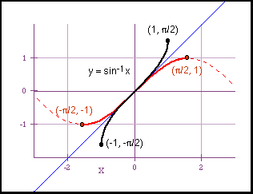

**(0,1)** => ( )

**(π/2, 0)** => ( )

(**π, –1)** => ( )

Exact values of sin –1 x, cos –1 x, etc. can be found by thinking about **what angle in the interval [–π/2, π/2] has a sin of x** (or [0, π] in the case of cos)? See steps on book pages 552, 554, and 556…

Example: Find the exact value of **sin –1(****/ 2)** and **sin –1(****/ 2)** with time

Rewrite θ = sin –1**(****/ 2)** as sin θ = **(****/ 2)** and find θ on interval [–π/2, π/2]

Tip – Don’t confuse domains of restricted trig functions with the domain on which the non-restricted functions complete a cycle

Example: Find the exact value of **cos –1( –1/2)** and **tan –1( –1)**

Calculators can also be used to obtain values of inverse trigonometric functions (usually on keys marked )

SIN -1

Example: Use a calculator to find the value to 4 dec. places of **cos –1( 1 / 3)** and **tan –1( –35.85)** and **sin –1( 3)**

You may recall in algebra seeing that with inverse functions f(f – 1(x)) = x and f – 1(f(x)) = x. We can apply this using our restricted trigonometry functions and inverses…

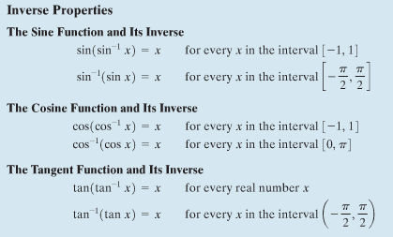

Note that when the outer function is the base (sin for example), the rule applies for the range of that function and when the outer function is the inverse (sin –1 for example), the rule applies for the restricted domains.

Example: Find the exact value of **cos(cos –1(0.7))**

Example: Examine online HW problems 9-10

We can use points and right triangles to find exact values of expressions involving the composition of a function and a different inverse function.

Example: Find the exact value of **sin(tan –1(3/4))**

Construct the triangle for which the tan θ = (3/4) and go from there

Example: Find the exact value of **cos(sin –1(–1/2))**