Section 4.8 (Applications of Trigonometric Functions)

There are many examples of periodic activity that can be examined using sinusoidal (trigonometric) functions including sound, tides, etc. One common use of trigonometric functions is being able to solve right triangles.

Example: Solve the right triangle seen on the … right of course
B

8.4
c

62.7º
b
C
A

Other examples and applications involve the solution of right triangles
Example: An engineer sets up a camera 100 ft. from the base of the Saturn V rocket in Huntsville to measure the height of the rocket. If the camera is positioned 5 ft. above ground and the angle of elevation is shown to be 74.4º, estimate the height of the rocket.

Example: One guy wire attached to the top Kermit the Frog float in the Thanksgiving parade is 102 feet long. Assuming the top of the float flies at ~100 ft. high, approximate the angle that the wire makes with the ground.

Example: Due to the popularity and utter domination of VA Tech in college football, congress has decided to include a sculpture of the face of the Hokie bird on Mount Rushmore. Designers have decided that on level ground 800 ft. from the base of the Mount, the angle of elevation to the bottom of the bird should be 32º and the angle to the top should be 35º. Find the height of the planned Hokie sculpture to the nearest tenth of a foot.

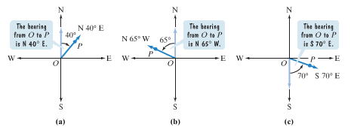In many navigation problems, the term bearing is used to specify the location of one point relative to another. The bearing from point O to point P is the acute angle between the ray OP and a north south line.

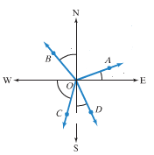Example: What is the bearing from O to B? O to C? O to D?

30º

10º
70º

20º

Example: Recently, Grover decided to do some hiking on Sesame Street’s expansive trail system. As he left the entrance, he hiked 2.3 miles on a bearing of S 31º W. Then the trail turned 90º clockwise, and he hiked 3.5 miles on a bearing of N 59º W. Upon arrival, Grover was how far (nearest tenth of a mile) from the entrance of the trail system? What was his bearing from the entrance to the trail system?

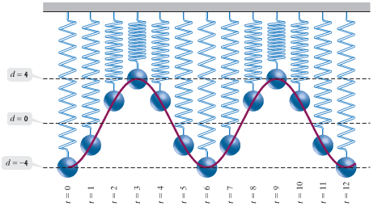Trigonometric functions are often used to model oscillatory and harmonic motion (consider radio waves, TV waves, sound waves). To better understand this, consider a ball hanging from a spring at a distance d. The position of the ball before being moved it at d = 0 (equilibrium), and as the ball is pulled down 4 inches (d = – 4) and released, it will take on different distances as it bobs up and down (simple harmonic motion – assuming no friction / air resistance – see pg. 555 for more details). Consider this situation over time…

An object that moves on a coordinate axis is in simple harmonic motion if its distance from the origin, d, at time t is given by either …

d = a cos t –or– d = a sin t Motion has amplitude (maximum displacement) |a| and period 2/ with >0

Example: A ball on a spring is pulled 6 inches below its rest position and then released. The period for the motion is 4 seconds. Write the equation for the ball’s simple harmonic motion.

In motion of this type, frequency describes the number of complete cycles per unit time (per second in the case above) and is the reciprocal of the period. Using the equations above for simple harmonic motion, the frequency can be given by f = /2 with >0 or equivalently f = 1/period

Example: An object moves in simple harmonic motion described by d = 12 cos() where t is measured in seconds and d in centimeters. Find the maximum displacement, the frequency, and the time required for one cycle.

Example (if time): Your favorite FM radio station, ______, has radio waves with a frequency of ______ million cycles per second. Write an equation of the form d = a sin t for the simple harmonic motion of the radio waves.

