Section 6.1 (The Law of Sines)

The relationships among sides and angles of right triangles defined by trig. functions thus far are not valid for oblique triangles (triangle that does not contain a right angle)

If A, B, and C are the angles of any triangle, and a, b, and c are the lengths of the opposite sides, then…

Law of Sines => $\frac{a}{\sin{A}}$ = $\frac{b}{\sin{B}}$ = $\frac{c}{\sin{C}}$ --- or --- $\frac{\sin{A}}{a}$ = $\frac{\sin{B}}{b}$ = $\frac{\sin{C}}{c}$

The derivation of this law comes from taking an oblique triangle, dropping down an altitude line, and examining the sines of the angles (see pg. 644)

The Law of Sines can be used to solve a triangle (find the lengths of all 3 sides and measurements of all 3 angles) in which one side and 2 angles are known (SAA and ASA)

Example: Solve the triangle shown on the right (SAA - round to nearest tenth)
64º
82º
A
B
b
a
c = 14 cm
C
Find the length of a and b and the measure of B

Example: Solve the triangle shown on the left (ASA - round to nearest tenth)
40º
22.5º
A
B
b = 12
a
c
C

What if we are given 2 sides and an angle opposite only 1 of those sides (SSA)? This can result in different possibilities that can still be determined using the Law of Sines.

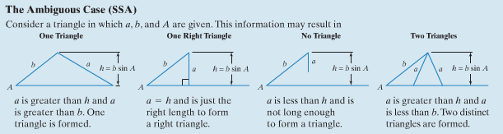

Example: Sketch and solve triangle ABC if A = 57º , a = 33, and b = 26 (SSA – round to nearest tenth)

Example: Sketch and solve triangle ABC if A = 50º , a = 10, and b = 20 (SSA – round to nearest tenth)

Example: Sketch and solve triangle ABC if A = 35º , a = 12, and b = 16 (SSA – round to nearest tenth)

You may recall that the formula for finding the area of a triangle is A = _________. Using this and applying the Law of Sines, we can find the area of an oblique triangle if we know the lengths of any 2 sides and their included angle (draw an altitude of length h from an unknown vertex – C in this case)
A
B
b
a
c
C
h
sin A = h / b and thus h =_______ => Area of triangle = (½)ch = (½)cb*sin A

The area of an oblique triangle = one-half the product of the lengths of 2 sides times the sin of the included angle

Area = (½)bc*sin A = (½)ab*sin C = (½)ac*sin B

Example: Find the area of a triangle having 2 sides of lengths 8 meters and 12 meters and an included angle of 62º (round to nearest square meter)

Example: Surveyor Mumford on Sesame Street is examining some distances across Big Bird River for a school project. The figure shows that 300 yards are measured along one bank on the opposite side. The angles from each end of this segment to Mumford are shown to be 62º and 53º. Find the distance between A and B to the nearest tenth of a yard.

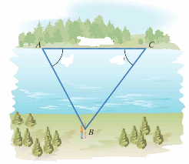
300 yds.
53º
62º

