Section 6.4 (Graphs of Polar Equations – OPTIONAL – No HW)

When plotting polar equations, we will typically utilize a polar grid. Just as with rectangular equations, we can use the point-plotting method to plot any polar equation

Example: See example 1 (pg. 675-6) and graph the equation r = 4 sin θ with θ in radians.

θ | r = 4 sin θ
0
π/6
π/3
π/2
2π/3
5π/6
π

The graphs of r = a cos θ and r = a sin θ are circles (what produces a graph of a circle centered around the origin?)
We can also use symmetry to graph polar equations more quickly

- Replace θ with – θ: same eqn. => symmetric w/ polar (x) axis
- Replace (r,θ) with (– r, – θ): same => symmetric w/ θ = π/2 (y)
- Replace r with – r: same => symmetric w/ pole (origin)

Example: Check for symmetry and graph the polar eqn. r = 1 + cos θ

Polar Axis (x) Line θ = π/2 (y) Pole (origin)

Below is a summary of some other types of graphs of polar equations (review in the book)…

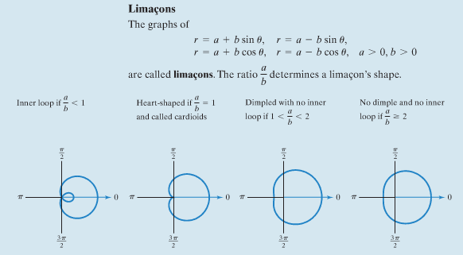

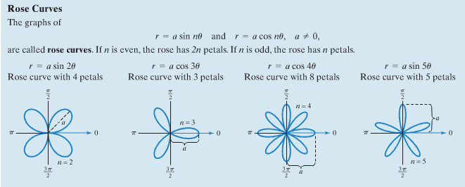

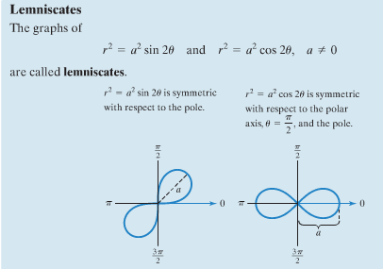
Examples: Graph the following…

r = 1 – 2 sin θ

r = 3 cos 2θ

r² = 4 cos 2θ

Example: Test for symmetry about the polar axis on r = 2 + cos θ

Symmetric Definitely not symmetric Maybe symmetric

