**Section 6.7** (The Dot Product)

In the last section, we examined vector addition and scalar multiplication, which resulted in vectors. In this section, we examine the **dot product** of two vectors, which results in a scalar value. If **v** = a**i** + b**j** and **w** = c**i** + d**j** are vectors, the dot product is defined as

**v • w** = ac + db

…the sum of the products of their horizontal components and their vertical components.

Example: If **v** = 7**i** – 4**j** and **w** = 2**i** – **j** , find **v • w** , **w • v** , and **w • w**

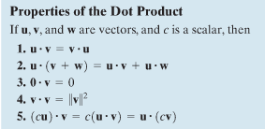

As seen in the example, dot products of vectors is commutative

(**v • w** = **w • v**). Other properties are listed on the right.

The Law of Cosines can be used to derive another formula for the dot product that gives us a way to find the angle between 2 vectors.

Considering the triangle formed by vectors **v** and **w** below and applying the Law of Cosines gives ||**u**|| = ||**v**||2 + ||**w**||2 – 2||**v**||||**w**||cosθ

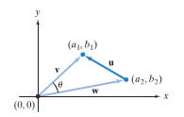Using the horizontal and vertical components for each vector and substitution we can simplify to **v • w** = ||**v**||||**w**||cos θ (see pg. 714)



Example: Find the angle between the vectors **v** = 4**i** – 3**j** and **w** = **i** + 2**j**

Two vectors are parallel when the angle between the vectors is 0o or 180o (point in the same or opposite directions). Two vectors are called orthogonal when the angle between them is 90o (vectors meet at right angles).

Example: What is the dot product of 2 vectors **v** and **w** that are orthogonal?

The converse of this dot product is also true. If the dot product of **v • w** is _______, the vectors are orthogonal.

Example: Are the vectors **v** = 2**i** + 3**j** and **w** = 6**i** – 4**j** orthogonal?

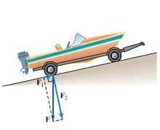We’ve examined how to add up 2 vectors to get a resultant vector, but what if we wanted to do the reverse? Consider a boat on a tilted ramp. The force due to gravity (**F**) is pulling straight down on the boat. Part of this force (**F1**) is pushing the boat down the ramp while another part of this force is pushing the boat down against the ramp at a right angle to the incline (**F2**). These 2 orthogonal vectors are called the vector components of **F** (**F** = **F1** + **F2**). A method for finding **F1** and **F2** involves projecting a vector onto another vector.

The vector projection of vector **v** onto vector **w** is proj**w v = $\frac{v•w}{{\left\|w\right\|}^{2}}$ w** (see explanation and graphs on pgs. 716-717 and example 4 for more details)

Example: If **v** = 2**i** – 5**j** and **w** = **i** – **j** find the projection of **v** onto **w**

Let **v** and **w** be 2 nonzero vectors. Vector **v** can be expressed as the sum of 2 orthogonal vectors **v1**and **v2** where **v1** is parallel to **w** and **v2** is orthogonal to **w**

**v1 =** proj**w v = w v2 = v – v1**

Example: Let **v** and **w** be the vectors defined in the previous example. Decompose **v** into 2 vectors **v1** and **v2** , where **v1** is parallel to **w** and **v2** is orthogonal to **w**

Work – The work (W) done by a force (F) in moving an object from A to B is (see pgs. 718 and 719)…

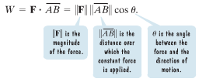

Consider the work you would do in pulling a suitcase (or book-bag) down a hallway (notice that there are 2 forces being applied – x and y or horizontal and vertical – this ties in with vector decomposition)…

Example: Cookie monster has loaded his bag full of cookies, and is trying to drag it down the hall to Trigonometry class (ground is level). He applies a force of 30 pounds on a handle that makes an angle of 50o with the ground. How much work does her perform in pulling the bag 150 feet?

