**Section 9.1** (The Ellipse)

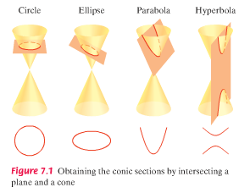Mathematics and the involvement of conic sections are present in many aspects of life, including the movement of planets, bridge and tunnel construction, navigation systems, manufacturing of lenses, etc. In this section, we look at the ellipse…

How is a circle defined (given a center, every point that is a certain distance from the center (radius) lies on the circle)? An ellipse is very similar but has 2 foci (focus points). An ellipse is the set of all points, where the sum of their distances from these foci is constant (consider 2 pins with a length of string between them and see figure 9.3 on pg. 874). The midpoint of the segment connecting the foci is the center of the ellipse.

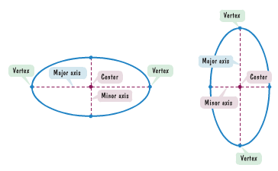Utilizing the rectangular coordinate system and triangles, we can derive the standard form for the equation of an ellipse (see pg. 875)…

$\frac{x^{2}}{a^{2}}$**+ $\frac{y^{2}}{b^{2}}$ = 1** (or x and y switched)

Here, the length of the major and minor axes is 2a and 2b, and the foci are on the major axis

(c,0) and (-c,0) or (0,c) and (0,-c) with c2 = a2 – b2

|  |  |  |  |  |  |  |  |  |  |  |  |
| --- | --- | --- | --- | --- | --- | --- | --- | --- | --- | --- | --- |
|  |  |  |  |  |  |  |  |  |  |  |  |
|  |  |  |  |  |  |  |  |  |  |  |  |
|  |  |  |  |  |  |  |  |  |  |  |  |
|  |  |  |  |  |  |  |  |  |  |  |  |
|  |  |  |  |  |  |  |  |  |  |  |  |
|  |  |  |  |  |  |  |  |  |  |  |  |
|  |  |  |  |  |  |  |  |  |  |  |  |
|  |  |  |  |  |  |  |  |  |  |  |  |

Example: Graph and locate the foci of $\frac{x^{2}}{36}$**+ $\frac{y^{2}}{9}$ = 1**



|  |  |  |  |  |  |  |  |  |  |  |  |
| --- | --- | --- | --- | --- | --- | --- | --- | --- | --- | --- | --- |
|  |  |  |  |  |  |  |  |  |  |  |  |
|  |  |  |  |  |  |  |  |  |  |  |  |
|  |  |  |  |  |  |  |  |  |  |  |  |
|  |  |  |  |  |  |  |  |  |  |  |  |
|  |  |  |  |  |  |  |  |  |  |  |  |
|  |  |  |  |  |  |  |  |  |  |  |  |
|  |  |  |  |  |  |  |  |  |  |  |  |
|  |  |  |  |  |  |  |  |  |  |  |  |

Example: Graph and locate the foci of **16x2 + 9y2 =144**

Example: Find the standard form of the eqn. of an ellipse with foci at (–2,0) and (2,0) and vertices (–3,0) and (3.0)

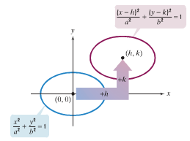Obviously, not all ellipses will be centered at the origin, so we need to consider the equation of an ellipse that has been translated elsewhere (this is the same as with circles)

The standard equation for ellipses centered at (h,k) is

$\frac{{(x-h)}^{2}}{a^{2}}$**+ $\frac{{(y-k)}^{2}}{b^{2}}$ = 1** (or a and b reversed)

Again, the foci are c units left/right (or above/below) the center of the ellipse with c2 = a2 – b2 (maj. axis – min. axis)

Example: Graph $\frac{{(x+1)}^{2}}{9}$**+ $\frac{{(y-2)}^{2}}{4}$ = 1**

|  |  |  |  |  |  |  |  |  |  |  |  |
| --- | --- | --- | --- | --- | --- | --- | --- | --- | --- | --- | --- |
|  |  |  |  |  |  |  |  |  |  |  |  |
|  |  |  |  |  |  |  |  |  |  |  |  |
|  |  |  |  |  |  |  |  |  |  |  |  |
|  |  |  |  |  |  |  |  |  |  |  |  |
|  |  |  |  |  |  |  |  |  |  |  |  |
|  |  |  |  |  |  |  |  |  |  |  |  |
|  |  |  |  |  |  |  |  |  |  |  |  |
|  |  |  |  |  |  |  |  |  |  |  |  |



We are not always given an equation in standard ellipse form, so we need to have a way to convert equations into this form. To convert a given equation, we need to complete the square. Consider the equation…

4x2 + 9y2 + 8x – 36y + 4 = 0 -- Move constant term to right side and group x and y terms

(4x2 + 8x) + (9y2 – 36y) = – 4 -- Make coefficients of x2 and y2 to be 1 by factoring groups

4(x2 + 2x) + 9(y2 – 4y) = – 4 -- Complete each square by adding the square of ½ x and y coefficients

[(1/2)(2)]2 = 1 and [(1/2)(–4)]2 = ______

4(x2 + 2x + 1) + 9(y2 – 4y + 4) = – 4 + 4 + 36 -- Why are we adding 4 and 36 to the right side? Factor terms…

4(x + 1)2 + 9(y – 2)2 = 36 -- Divide both sides by right side to get 1 on right side

+ = 1 -- Standard form

Example: Convert the equation into standard form 4x2 + y2 – 8x + 4y – 8 = 0

There are many applications involving ellipses (including planet/satellite orbit with the sun/earth as a focus – see whispering room factoid on pg. 881, disintegrating kidney stones, arches in tunnels, bridges, etc.)

Example: Watch ellipse example video in online multimedia library