**Section 9.2** (The Hyperbola)



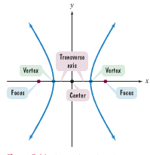A hyperbola effectively has 2 branches out from the center similar to what you might see in a lampshade. Whereas an ellipse looked at the sum of the distances between 2 foci being constant, the hyperbola utilizes the difference of the distances between 2 foci being constant (pick a point on the hyperbola and look at the distances to each focus point)

Similar to the technique used in deriving the ellipse formula, letting the differences in the distances be 2a (|d1 – d2| = 2a), we can get the standard form of the equation of a hyperbola centered at the origin…

$\frac{x^{2}}{a^{2}}$**– $\frac{y^{2}}{b^{2}}$ = 1** (or x and y switched, changing transverse axis)

Vertices are a and foci are c units away on the transverse axis (x or y, whichever is positive) with c2 = a2 + b2

Example: Find the vertices and locate the foci of each of the following hyperbolas…

$\frac{x^{2}}{25}$**– $\frac{y^{2}}{16}$ = 1 $\frac{y^{2}}{25}$** **– $\frac{x^{2}}{16}$ = 1**

Example: Find the standard form of a hyperbola with foci at (0,– 5) and (0,5) and vertices (0,– 3) and (0,3)

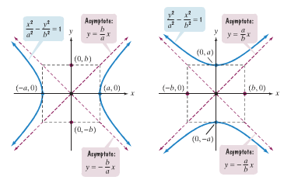

In examining a hyperbola, we could see that as x and y values get larger, the graph approaches a pair of intersecting straight lines (asymptotes). These asymptotes pass through the corners of the rectangle formed by the a-values (transverse axis) and the b-values (conjugate axis). Using right triangles, we can find the equation of these asymptotes…

**y = $±\frac{b}{a}$ x** (…or **y = $±\frac{a}{b}$ x** )

We can graph hyperbolas centered at the origin using vertices and asymptotes…

1. Locate the vertices
2. Use dashed lines to sketch out rectangle correctly
3. Use dashed lines to draw diagonals of rectangle and extending
4. Draw 2 branches of rectangle starting at each vertex and approaching asymptotes

Example: Graph and locate the foci of the following and list the equations of the asymptotes

**– = 1 y2 – 4x2 = 4**

|  |  |  |  |  |  |  |  |  |  |  |  |
| --- | --- | --- | --- | --- | --- | --- | --- | --- | --- | --- | --- |
|  |  |  |  |  |  |  |  |  |  |  |  |
|  |  |  |  |  |  |  |  |  |  |  |  |
|  |  |  |  |  |  |  |  |  |  |  |  |
|  |  |  |  |  |  |  |  |  |  |  |  |
|  |  |  |  |  |  |  |  |  |  |  |  |
|  |  |  |  |  |  |  |  |  |  |  |  |
|  |  |  |  |  |  |  |  |  |  |  |  |
|  |  |  |  |  |  |  |  |  |  |  |  |



|  |  |  |  |  |  |  |  |  |  |  |  |
| --- | --- | --- | --- | --- | --- | --- | --- | --- | --- | --- | --- |
|  |  |  |  |  |  |  |  |  |  |  |  |
|  |  |  |  |  |  |  |  |  |  |  |  |
|  |  |  |  |  |  |  |  |  |  |  |  |
|  |  |  |  |  |  |  |  |  |  |  |  |
|  |  |  |  |  |  |  |  |  |  |  |  |
|  |  |  |  |  |  |  |  |  |  |  |  |
|  |  |  |  |  |  |  |  |  |  |  |  |
|  |  |  |  |  |  |  |  |  |  |  |  |

Obviously, not all hyperbolas are centered at the origin and may be translated (techniques remain the same, but vertices, foci, asymptotes are now in relation to the new center point)…

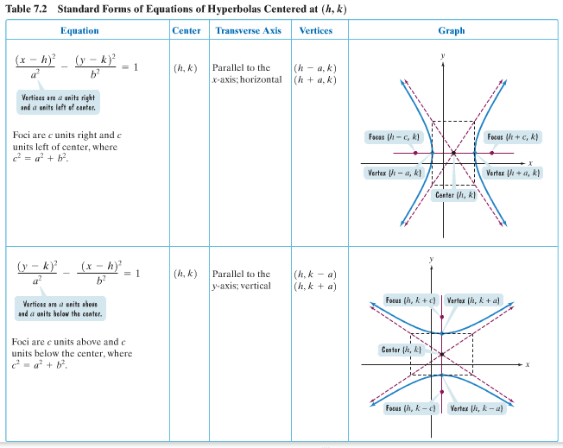

Examples: Do some of numbers 3, 8, 9 from online HW depending on time

Example: Convert to standard form by completing the square

**x2 – y2 – 8x – 8y – 1 = 0**  **4x2 – 24x – 9y2 – 90y – 153 = 0**

Review example 7 application (post-class)