**Section 9.3** (The Parabola)

Parabolas are explored in Pre-Calculus Algebra (having the form y = a(x – h)2 + k or y = ax2 + bx + c), so we will look at a couple different attributes in this class

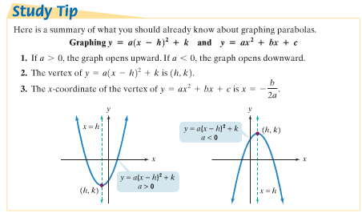A parabola is the set of all points in a plane that are equidistant from a fixed line (directrix) and a fixed point (focus) not on the line

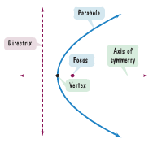

Measuring the distances to a point on a parabola from the focus (p,0) and directrix (-p,y) as d1 = d2, we can use distance formulas to derive another form for parabolas with a vertex at the origin (see derivation on pgs. 901-902) as **y2 = 4px** (opens right/left with focus on x-axis of symmetry) or **x2 = 4py** (opens up/down with focus on y-axis)

Example: Find the focus and directrix of the parabola given by the following equations and graph using points above/below or left/right of the focus (notice that these points are +/- 2p from the focus)

**y2 = 8x x2 = –12y**

4p = ______ …

|  |  |  |  |  |  |  |  |  |  |  |  |
| --- | --- | --- | --- | --- | --- | --- | --- | --- | --- | --- | --- |
|  |  |  |  |  |  |  |  |  |  |  |  |
|  |  |  |  |  |  |  |  |  |  |  |  |
|  |  |  |  |  |  |  |  |  |  |  |  |
|  |  |  |  |  |  |  |  |  |  |  |  |
|  |  |  |  |  |  |  |  |  |  |  |  |
|  |  |  |  |  |  |  |  |  |  |  |  |
|  |  |  |  |  |  |  |  |  |  |  |  |
|  |  |  |  |  |  |  |  |  |  |  |  |



|  |  |  |  |  |  |  |  |  |  |  |  |
| --- | --- | --- | --- | --- | --- | --- | --- | --- | --- | --- | --- |
|  |  |  |  |  |  |  |  |  |  |  |  |
|  |  |  |  |  |  |  |  |  |  |  |  |
|  |  |  |  |  |  |  |  |  |  |  |  |
|  |  |  |  |  |  |  |  |  |  |  |  |
|  |  |  |  |  |  |  |  |  |  |  |  |
|  |  |  |  |  |  |  |  |  |  |  |  |
|  |  |  |  |  |  |  |  |  |  |  |  |
|  |  |  |  |  |  |  |  |  |  |  |  |



Example: Find the standard form of the equation of a parabola with focus **(8,0)** and directrix **x = –8**

Again, not all parabolas are centered at the origin and may be translated (techniques remain the same, but vertices, foci, directrix are now in relation to the new center point) – see figures in book…

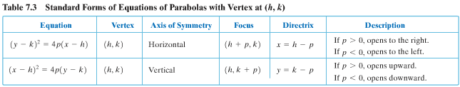

Example: Find the vertex, focus, and directrix of the following (and graph if time)

**(x – 2)2 = 4(y + 1) y2 + 2y + 4x – 7 = 0**

There are many applications of parabolas including arches/cables for bridges, solar cookers, reflectors for lights (flashlights), satellite dishes, etc.

Example: Cookie Monster is making an effort to go green, so he has decided to make a solar cooker to help him bake cookies (satellite dish basically) with a diameter of 6 feet and a depth of 1 foot. Where should he put the cooker (focus) to get the maximum reflected sun rays to bake the cookies?

Review online HW in class with time