Sections 9.4 and 9.6 Summary (Rotation of Axes / Conic Sections in Polar Coordinates)

Section 9.4 (Rotation of Axes)

Given a conic equation (Ax² + Cy² + Dx + Ey + F = 0) not in standard form such as ., we can determine which conic section we have by examining A, C, and AC (coefficient of x², y²)…

A = C, circle AC = 0, parabola AC > 0, ellipse AC < 0, hyperbola

Example: Identify the graph of each of the following

3x² + 2y² + 12x – 4y + 2 = 0

x² + y² – 6x + y + 3 = 0

y² – 12x – 4y + 52 = 0

9x² – 16y² – 90x + 64y + 17 = 0

The presence of an xy-term in conic equations sometimes rotates the conic over a given angle
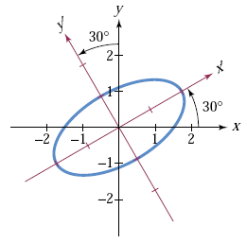
See page 916 and Example 2 in the book (and Ex. 3 result on pg. 920)
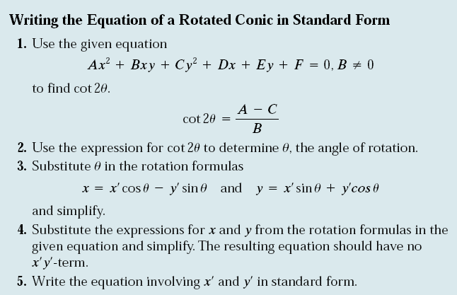

Section 9.6 (Conic Sections in Polar Coordinates)

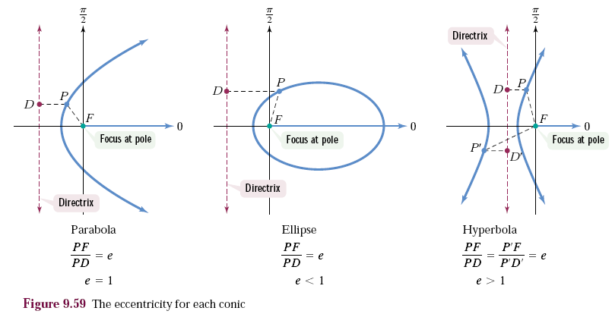
Another way to represent conic sections is through polar equations (remember r, θ) using eccentricity

Equation Forms :

r = $\frac{ep}{1+/-e\cos{θ}}$

r = $\frac{ep}{1+/-e\sin{θ}}$

e = eccentricity

p = dist. from focus
to directrix

SEE BOOK EXAMPLES FOR MORE

