Section 1.4 (Continuity and One-Sided Limits)

A function f(x) is continuous at x = c if there is no interruption in the graph at c (no holes, jumps, gaps). Consider the following conditions…
- f(c) is defined 2. $\lim_{x→c}{f(x)}$ exists 3. $\lim_{x→c}{f(x)}=f(c)$

Examples: Discuss the continuity of the following functions (sketch graphs if time)…

f(x) = $\frac{2}{x}$ g(x) = $\frac{x^{2}-4}{x-2}$ h(x) = $\left\{\begin{aligned}x+2 x≤0 \\ x^{2}+2 x>0\end{aligned}\right.$ y = cos(x)

- Discuss removable vs. non-removable discontinuities

Examples: Review one-sided limits by examining the one-sided limits of the following functions…

$\lim_{x→3}{\sqrt{9-x^{2}}}$ $\lim_{x→1}{⟦x⟧}$ where f(x) = [[x]] is the greatest integer function (step function)
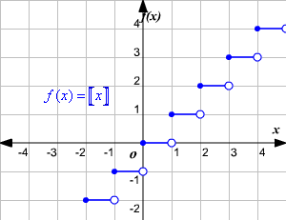

The existence of a limit:

The limit of f(x) as x approaches c is L if and only if

$\lim_{x→c^{-}}{f\left(x\right)}=L$ and $\lim_{x→c^{+}}{f\left(x\right)}=L$

Example: Discuss the continuity of f(x) = $\sqrt{4-x^{2}}$ using the definition below

Definition of continuity on a closed interval:

A function f(x) is continuous on the closed interval [a,b] if it is continuous on the interval (a,b) and

$\lim_{x→a^{-}}{f\left(x\right)}=f\left(a\right)$ and $\lim_{x→b^{+}}{f\left(x\right)}=f(b)$ The function f is continuous from the right at a (left at b)

Example: Review example 5 from this section in the book and determine the value of absolute zero on the Fahrenheit scale (use Charles’s Law stating that the Volume of a gas at constant pressure increases linearly with the Temperature of the gas)

T | - 40 | - 4 | 32 | 68 | 104 | 140 | 176
V | 19.1482 | 20.7908 | 22.4334 | 24.076 | 25.7186 | 27.3612 | 29.0038

V = mT + b m = V = T =

$\lim_{x→0^{+}}{T}=\lim_{x→0^{+}}$

If b is a real number and f and g are continuous at x = c, then the following functions are also continuous at c…

1. Scalar multiple: bf 2. Sum or difference: f ± g 3. Product: fg 4. Quotient: f / g (g(c) ≠ 0)

Also, polynomial, rational, radical, and trigonometric functions are continuous at every point in their domains (and composite functions where g is continuous at c and f continuous at g(c) – f(g(x)) is continuous at c – theorem 1.12)

Examples: Describe the interval(s) on which each function is continuous…

f(x) = cot(x) g(x) = $\left\{\begin{aligned}cos(1/x), x≠0 \\ 0, x>0\end{aligned}\right.$ h(x) = $\left\{\begin{aligned}xcos(1/x), x≠0 \\ 0, x>0\end{aligned}\right.$

The Intermediate Value Theorem (1.13) describes the behavior of functions that are continuous on a closed interval

If f is continuous on the closed interval [a,b], f(a) ≠ f(b), and k is any number between f(a) and f(b), then there is at least one number c in [a,b] such that f(c) = k

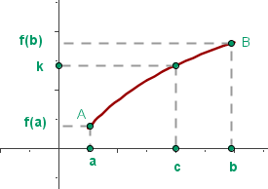

Application Example: In an effort to spend more time outdoors after the holidays, Grover has decided to go camping. At 8 am on Saturday morning, Grover begins running up the side of a mountain to his weekend campsite. On Sunday morning at 8, he runs back down the mountain. It takes him 20 minutes to run up the mountain but only 10 minutes to run down. At some point on his way down, he realizes that he passed the same place at exactly the same time on Saturday. Prove he is correct (see #107 – use s(t) and r(t) be the position functions for the runs up and down, applying the Intermediate Value Theorem to the function f(t) = s(t) – r(t))

- Discuss the bisection method for approximating the real zeros of a continuous function with time

