Section 2.1 (The Derivative and the Tangent Line Problem)

One of the major problems that instantiated Calculus was the tangent line problem, where you are given a function f and a point P on its graph and are asked to find the equation of the tangent line (essentially the slope of the tangent line) to the graph at that point. Examine the graphics below (SKETCH GRAPHS ON BOARD) and see how the slope of secant lines approach the slope of the tangent line as the differences in x-values get smaller and smaller…

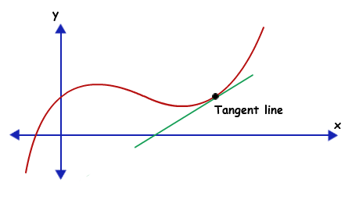

The slope of a secant line around point x = c can be given as m_{sec} = $\frac{y_{2}-y_{1}}{x_{2}-x_{1}}$ = $\frac{f(c+∆x)-f(c)}{\left(c+∆x\right)-c}$ = $\frac{f(c+∆x)-f(c)}{∆x}$, where (c,f(c)) is the point of interest and (c+∆x, f(c+∆x)) are the coordinates of the point of the graph that is ∆x units away. This is written in many texts as
m_{sec} = $\frac{f(x+h)-f(x)}{h}$

I will commonly use this as the difference quotient for this class.Furthermore, if f is a function defined on an open interval containing c, then the slope of the tangent line at x = c can be given as

m_{tan} = $\lim_{h→0}{\frac{f(x+h)-f(x)}{h}}$

where h represents the change in x (∆x) approaching 0.

Examples: Find the slopes of the tangent lines to the following at the given points (slope of the graph)

f(x) = 2x – 1 at x = 3 f(x) = x² + 3 at x = 0 and x = 2

(notice the constant slope) (sketch graph if time)

Notice with the graphic below and examining the limit definition that if the m_{tan} = ± ∞, then the function has a vertical tangent line at x = c.
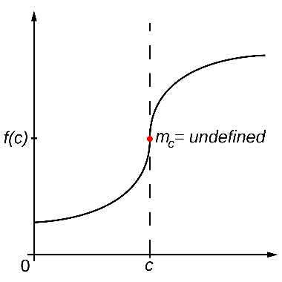

The derivative of f at x is f ’(x) = $\lim_{h→0}{\frac{f(x+h)-f(x)}{h}}$ , provided the limit exists.

This derivative is also a function of x and gives the slope(s) of the tangent line(s) to the graph of f. The process of finding the derivative of a function is called differentiation. A function is differentiable at x if its derivative exists at x and is differentiable on an open interval (a,b) if it is differentiable at every point on that interval. In addition to f ‘(x), other notations you might see are $\frac{dy}{dx}$ , y ’, $\frac{d}{dx}$[f(x)], D_{x}[y],…
Examples: Find the derivative of the following functions…

f(x) = x³ – 2x g(x) = $\sqrt{x}$ y = f(t) = $\frac{3}{t^{2}}$

Find f ‘(2) and the slope of the graph of g(x) at x = 1, 4, and 0

Review examples 6 and 7 in the book and the following summarization of differentiability and continuity

- If a function is differentiable at x = c, then it is continuous at c.
- The converse is not necessarily true. It is possible for a function to be continuous at x = c and not be differentiable at x = c.

