Section 2.6 (Related Rates)

When water is drained from a cylindrical tank, the volume V, the radius r, and the height h of the water level are all functions of time t. These variables are related by the equation V = π r² h. You can differentiate implicitly to obtain the related rate equation…

$\frac{d}{dt}$ (V) = $\frac{d}{dt}$ (π r² h) = π [r² $\frac{dh}{dt}$ + h (2r $\frac{dr}{dt}$ )] = π [r² $\frac{dh}{dt}$ + 2rh $\frac{dr}{dt}$ )],

Showing that the rate of change in volume is related to the rates of change in both h and r.

Example: Suppose x and y are both differentiable functions of t and are related by the equation y = 3x² – 4. Find dy/dt when x = 2, given that dx/dt = 4 when x = 2.

In the previous example, you were essentially given the equations and values. In remaining examples, you will need to create the mathematical models to be used.

Example: The rocket city rednecks have set up a television camera at ground level to file the lift-off of a new Space-X rocket. The position equation of the rocket’s rise is estimated to be s = 60t², where s is measured in feet and t in seconds. The camera is on level ground and placed 2200 feet from the launch pad. Find the rate of change in the angle of elevation of the camera at t = 5 seconds and t = 10 seconds.

θ
_____

Example: Ernie does a cannonball into a still pool of water, forming ripples in the form of concentric circles. The radius r of the outer ripple is increasing at a rate of 3 feet per second. When the radius is 9 feet, at what rate is the total area A of the water changing?

Example: An airplane is flying on a flight path that will take it directly over a radar tracking station (see example 4 in the book). If the ground range is decreasing at a rate of 300 miles per hour (assume level ground) when the slant range is 12 miles, what is the speed of the plane if the plane flies at a constant altitude of 5 miles?

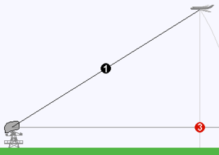

--- Complete homework exercises and get examples from students / other sources with time ---

