Section 3.2 (Rolle’s Theorem and the Mean Value Theorem)

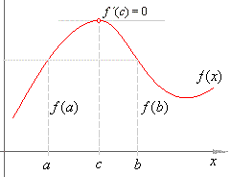
Rolle’s Theorem: Let f be continuous on the interval [a,b] and differentiable on the open interval (a,b). If f(a) = f(b) then there is at least one number c in (a,b) such that f `(c) = 0.

The graphic on the right demonstrates this (what if the function did not have to be differentiable on (a,b))

Example: Find the two x-intercepts of f(x) = x² – 5x + 6 and show that f `(x) = 0 at some point between the intercepts.

Example: Let f(x) = x⁴ – 2x². Find all values of c in the interval (-2,2) such that f `(c) = 0

An extension of Rolle’s Theorem and important theorem in calculus is the Mean Value Theorem…

Mean Value Theorem: If f is continuous on the interval [a,b] and differentiable on the interval (a,b), then there exists a number c in (a,b) such that…
$$f^{'}\left(c\right)=\frac{f\left(b\right)-f(a)}{b-a}$$
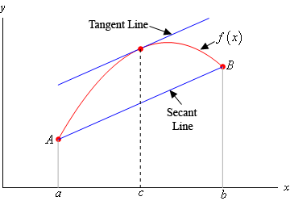
Neat Implications:
- Existence of a tangent line parallel to the secant line through (a,f(a)) and (b,f(b))
- There is a point in the open interval (a,b) at which the instantaneous rate of change is equal to the average rate of change over [a,b]

Example: Given f(x) = x² – 5x + 7, find all values c in the open interval (-1,3) that satisfy the Mean Value Theorem.

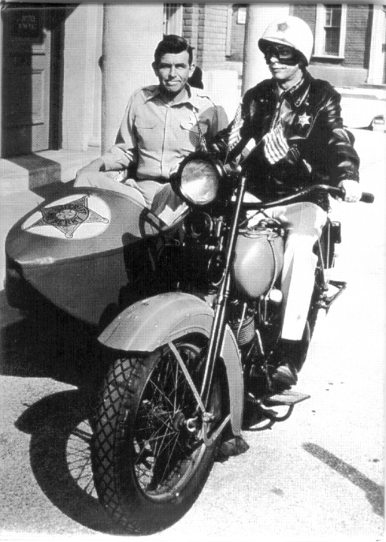
Example: I’ve decided to set up a speed trap to prove that cars are speeding on I565. I stationed 2 patrol cars 10 miles apart. As a car passes the first patrol, its speed is clocked at 70 miles per hour. Six minutes later when the car passes the second patrol, its speed is clocked at 65 mph. Prove that the car must have exceeded the speed limit (70).

