Section 3.4 (Concavity and the Second Derivative Test)

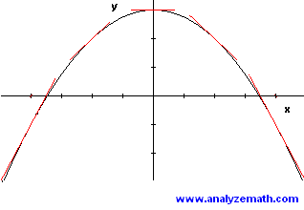
Examine the slopes of the tangent lines in the following graph of a concave down function.

Is there a critical point? relative maximum / minimum?

Are the slopes increasing or decreasing?

If f ``(x) > 0 for all x in a given interval (2nd derivative is positive, meaning that the slopes of the tangent lines are increasing), then f(x) is concave up on that interval.

If f ``(x) < 0 for all x in a given interval (2nd derivative is negative, meaning that the slopes of the tangent lines are decreasing), then f(x) is concave down on that interval.

What if f ``(x) = 0?

Example: Determine open intervals on which the graph of f(x) = x³ – 3x² + 1 is concave up or concave down.

Example: Determine open intervals on which the graph of f(x) = $\frac{x^{2}+1}{x^{2}-4}$ is concave up or concave down.

A point of inflection on the graph of f is a point (f ``(x) = 0) where concavity changes from down to up (or vice versa)

Example: Find the points of inflection and discuss concavity of f(x) = 2x⁴ – 8x + 3

Second derivative test when f `(c) = 0 and f ``(c) exists:

- If f ``(c) > 0, then f has a relative minimum at (c,f(c))
- If f ``(c) < 0, then f has a relative maximum at (c,f(c))

Example: Find all relative extrema of f(x) = x³ – 5x² + 7x

